Name:
Class: D15C
Roll. No:
Experiment 04: Exploratory Data Analysis and Visualization
Aim:
To perform exploratory data analysis (EDA) and data visualization on the loan dataset using Python.
Theory:
Dataset Overview:
The dataset used in this study contains 614 instances of loan applications, with 13 attributes describing applicant demographics, financial details, and loan characteristics. The columns include Loan_ID, Gender, Married, Dependents, Education, Self_Employed, ApplicantIncome, CoapplicantIncome, LoanAmount, Loan_Amount_Term, Credit_History, Property_Area, and Loan_Status (the target variable, Y/N). EDA is performed on the raw dataset to understand its natural characteristics before preprocessing, which was addressed in Experiment 03.
Significance of EDA for Loan Approval Prediction:
EDA is a crucial step in data analysis and model building. Here’s why:
- Data Cleaning & Quality Check:
  - Identifies missing values, inconsistencies, and outliers (e.g., extreme ApplicantIncome values).
- Understanding Data Distribution:
  - Visualizes distributions (e.g., skewness in ApplicantIncome) to guide preprocessing steps.
- Identifying Key Features:
  - Determines which features (e.g., Credit_History) influence loan approval.
  - Helps eliminate redundant variables.
- Detecting Relationships & Patterns:
  - Correlation analysis reveals dependencies (e.g., between ApplicantIncome and LoanAmount).
  - Useful for feature selection in machine learning.
- Improving Model Interpretability:
  - Helps choose appropriate preprocessing techniques (e.g., normalization for skewed data).
  - Assists in selecting models based on feature relationships.
1. Descriptive Analysis - Statistical Measures of Central Tendency
- Central tendency measures indicate the "center" of the data distribution.
- Includes:
  - Mean: Represents the average value (e.g., typical ApplicantIncome).
  - Median: The middle value, robust to outliers (e.g., for LoanAmount).
  - Mode: The most frequent value, useful for categorical data (e.g., Gender).
- Relevance:
  - The average ApplicantIncome highlights typical applicant earnings.
  - The median LoanAmount avoids skew from outliers.
  - The mode of Dependents shows the most common family structure.
2. Descriptive Analysis - Statistical Measures of Dispersion
- Dispersion measures the spread of data.
- Includes:
  - Standard Deviation: Shows deviation from the mean.
  - Variance: Quantifies spread (squared standard deviation).
  - Range: Difference between maximum and minimum values.
  - Interquartile Range (IQR): Range of the middle 50%, useful for outlier detection.
- Relevance:
  - High variance in ApplicantIncome indicates diverse earnings.
  - IQR of LoanAmount helps identify typical loan sizes and outliers.
  - Standard deviation of Credit_History shows consistency in credit profiles.
3. Correlation Between Attributes
- Correlation measures the strength of relationships between variables.
- The Pearson correlation coefficient (-1 to +1) helps determine:
  - If ApplicantIncome and LoanAmount are correlated, higher incomes might lead to larger loans.
  - If Credit_History correlates with Loan_Status, it’s a key predictor.
- Relevance:
  - Identifies key predictors for loan approval.
  - Detects multicollinearity to remove redundant features.
  - Guides feature selection for modeling.
4. Different Visualization Techniques & Their Uses
Visualizations help interpret patterns, detect anomalies, and support inferences. Suitable methods include:
- Histogram: Shows distributions (e.g., ApplicantIncome).
- Boxplot: Highlights outliers and comparisons (e.g., LoanAmount by Loan_Status).
- Heatmap: Visualizes correlations.
- Scatter Plot: Analyzes relationships (e.g., ApplicantIncome vs. LoanAmount).
Code:
Step 1: Loading the Dataset and Initial Exploration
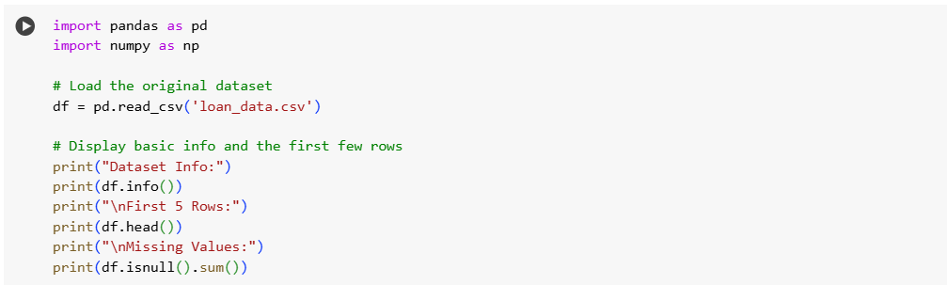
Output:
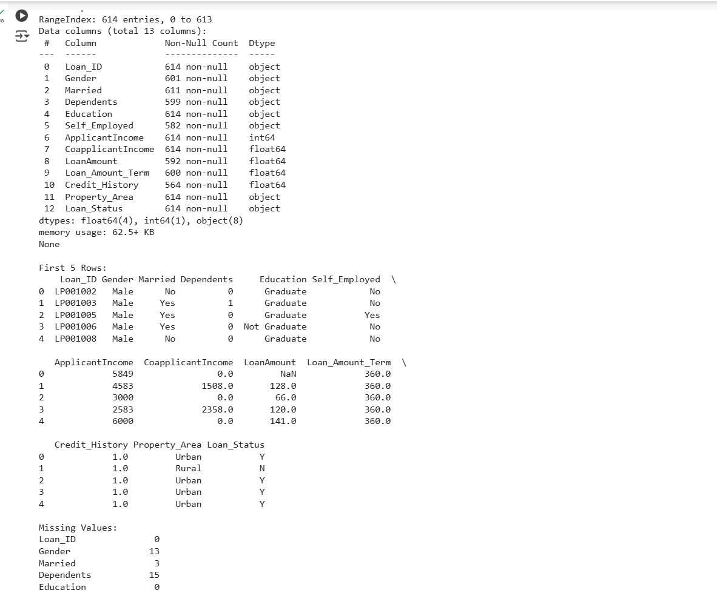

Step 2: Task 1 - Descriptive Analysis - Statistical Measures of Central Tendency
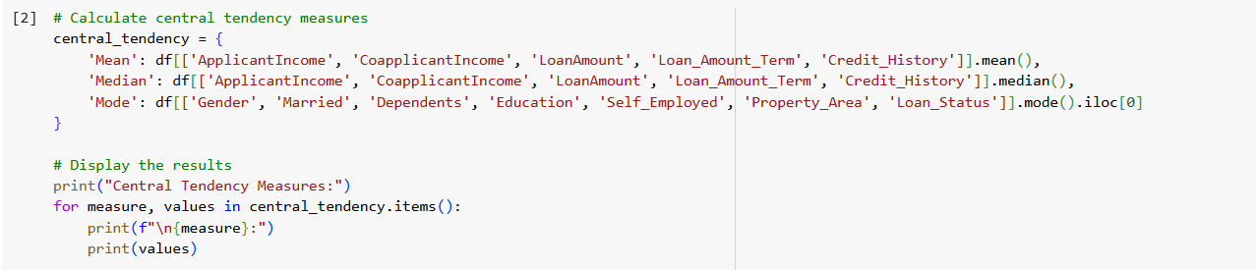
Output:
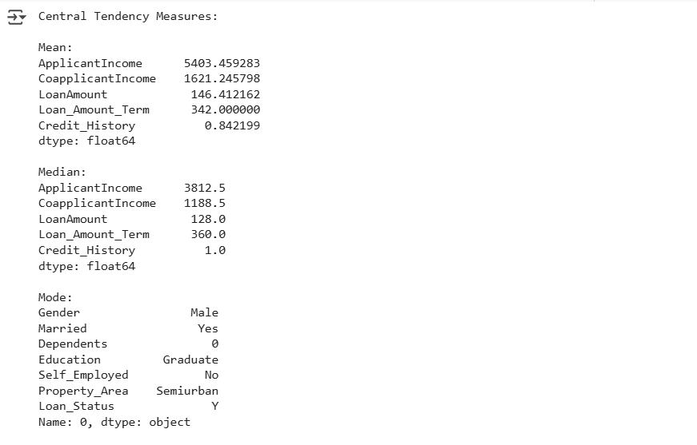

Inferences:
- The mean ApplicantIncome (5403) is higher than the median (3812), indicating a right-skewed distribution with some high-income outliers.
- The median CoapplicantIncome (0) suggests most applicants don’t have a coapplicant, while the mean (1621) is pulled up by a few high values.
- The mode shows most applicants are male, married, with no dependents, graduated, not self-employed, living in semiurban areas, and have their loans approved.
- Insight: The typical applicant earns around 3812, requests a loan of 128, and has a good credit history (1), with loan approval being more common.

Step 3: Task 2 - Descriptive Analysis - Statistical Measures of Dispersion
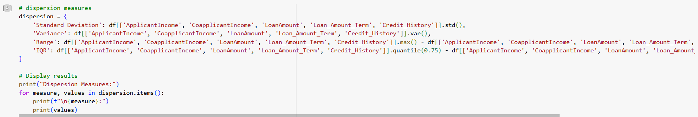
Output:
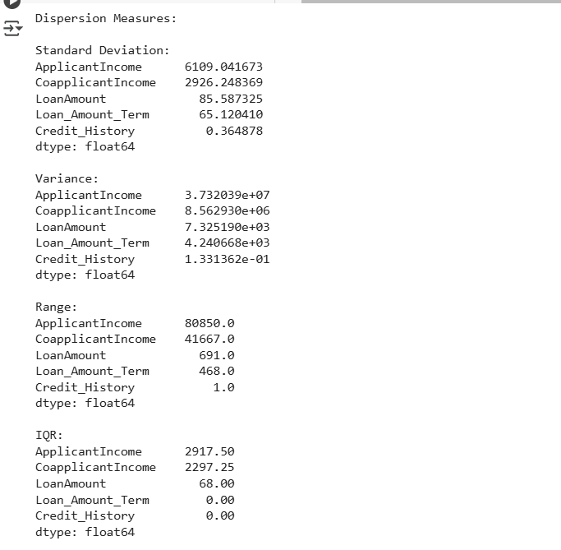
Inferences:
- ApplicantIncome has a high standard deviation (6199) and range (80850), indicating significant variability, likely due to a few high earners.
- CoapplicantIncome (std 2926, range 41667) and LoanAmount (std 85.6, range 691) also show variability, with outliers affecting the spread.
- Loan_Amount_Term (IQR 0) and Credit_History (IQR 0) have minimal variation in the middle 50%, suggesting most loans have a standard term (360 months) and good credit history (1).
- Insight: The wide spread in income and loan amount highlights the need for outlier handling, while the uniformity in loan term and credit history suggests these might be stable predictors.

Step 4: Task 3 - Correlation Between Attributes
- 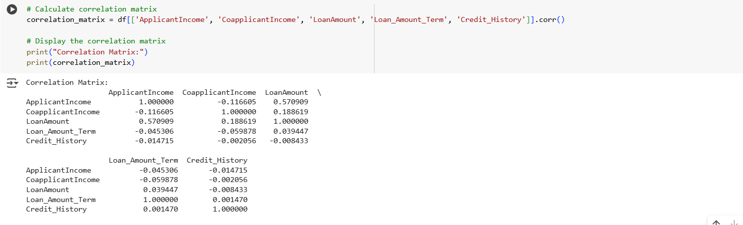
Inferences:
- A moderate positive correlation (0.57) between ApplicantIncome and LoanAmount indicates higher-income applicants tend to request larger loans.
- Credit_History shows weak correlations with other features, suggesting it provides independent information.
- Most correlations are weak, reducing the risk of multicollinearity in modeling.
- Insight: ApplicantIncome and LoanAmount are key related features, while Credit_History’s role might be better understood with Loan_Status.

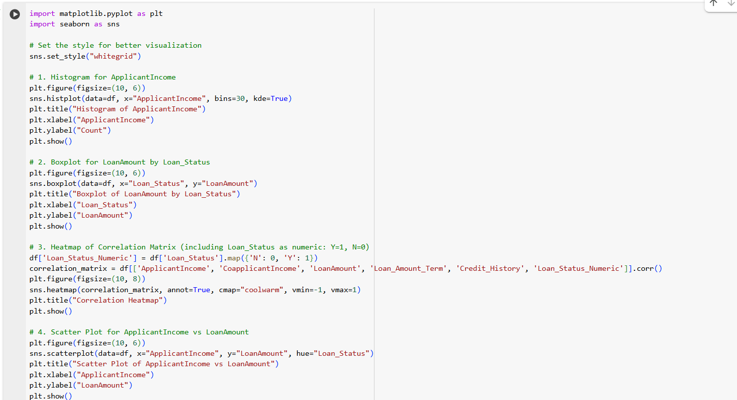
Output:
  - Histogram of ApplicantIncome: Right-skewed distribution, peak at 0-5000, long tail to 80000.
  - 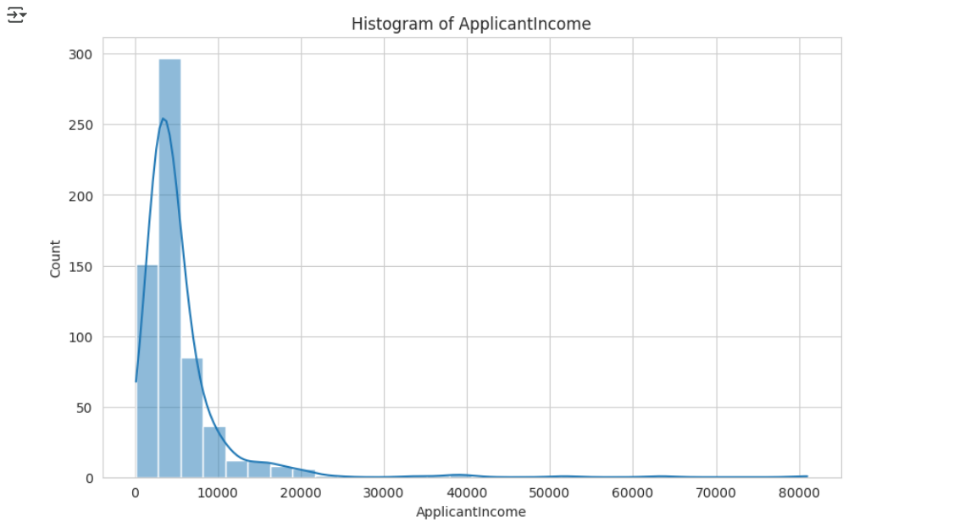
  - Boxplot of LoanAmount by Loan_Status: 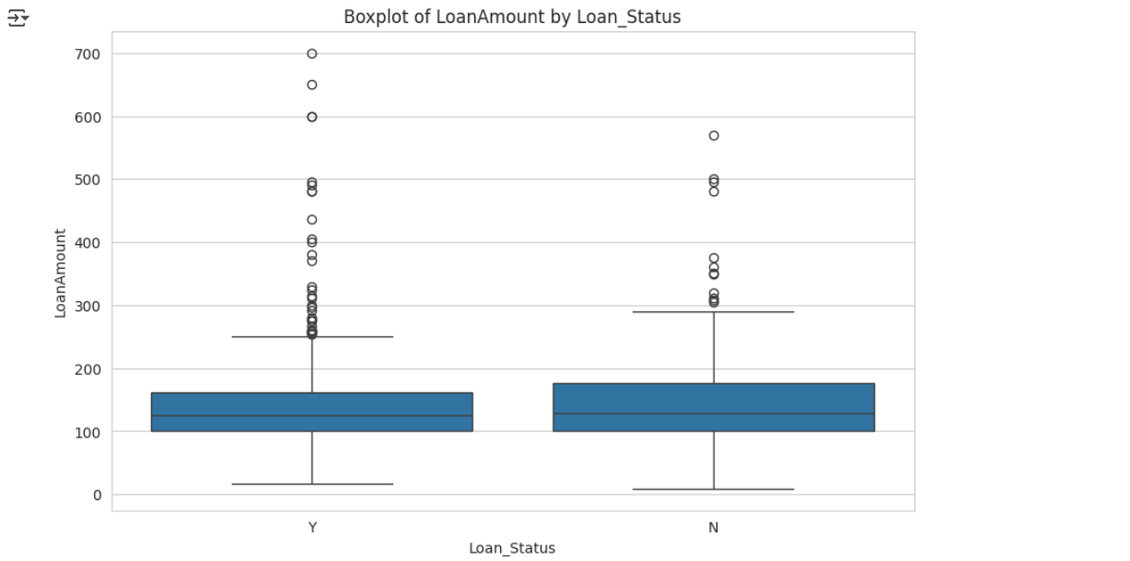
  - Correlation Heatmap: ApplicantIncome vs. LoanAmount (0.57), Credit_History vs. Loan_Status_Numeric (0.56), other correlations weak.
  - 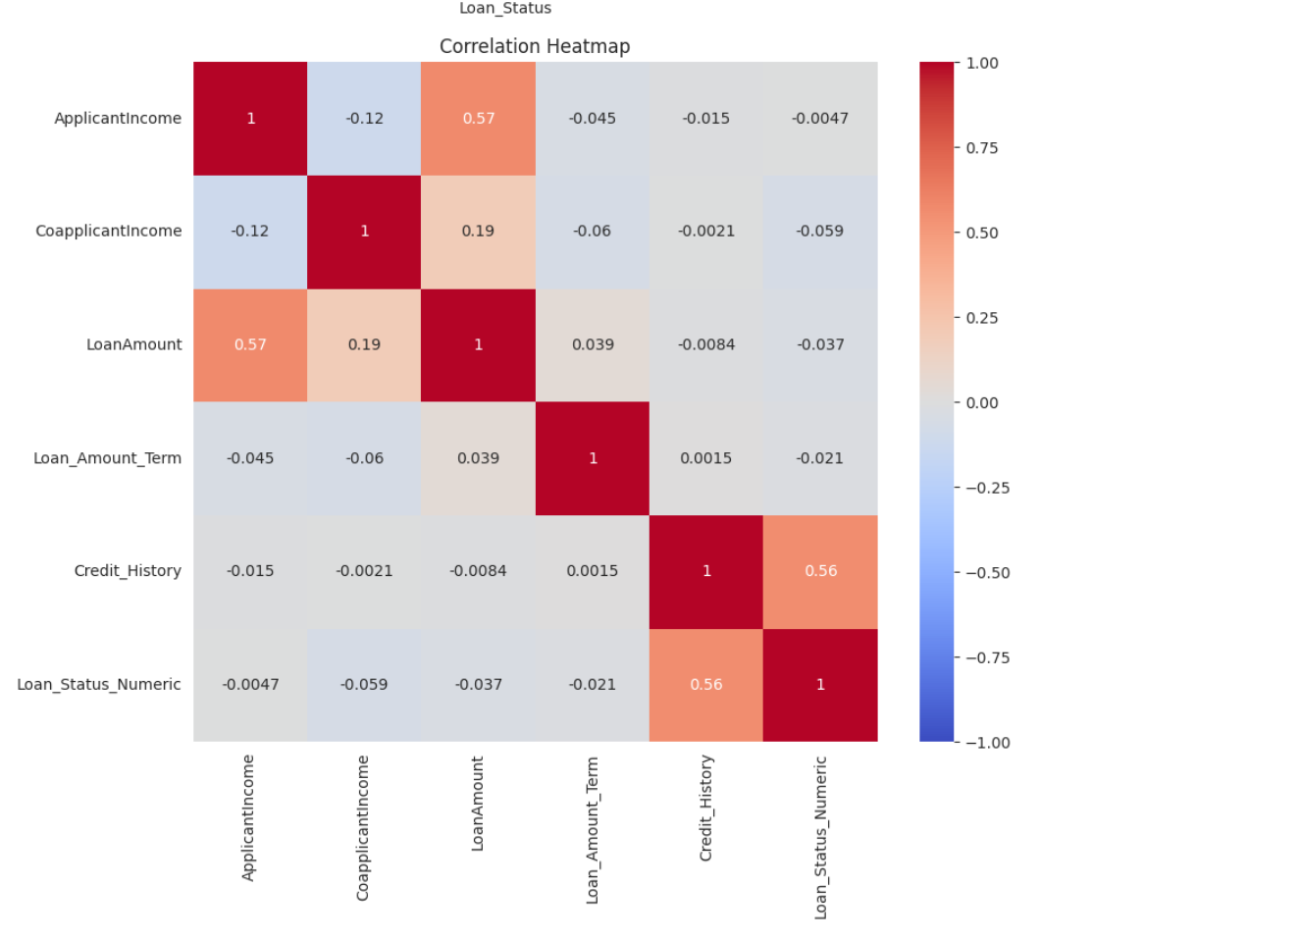
  - Scatter Plot of ApplicantIncome vs LoanAmount: Positive trend, clustering below 20000 income and 300 loan amount, more approved (Y) loans across all ranges.
  - 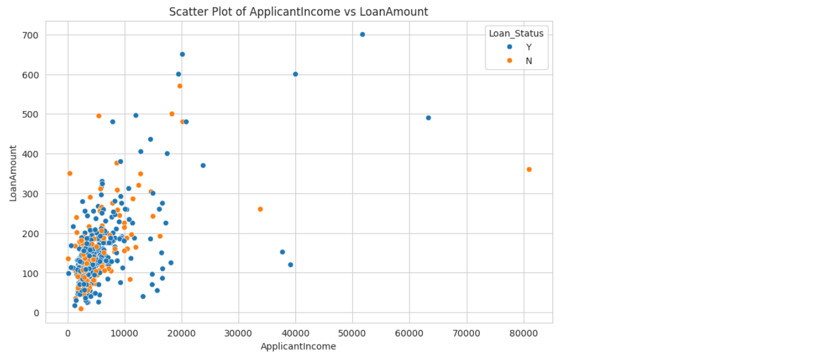
Inferences:
- Histogram: ApplicantIncome is right-skewed, with most applicants earning below 5000, indicating a need for transformation or outlier handling.
- Boxplot: LoanAmount distributions are similar for approved (Y) and rejected (N) loans, with outliers more pronounced for Y, suggesting loan size alone isn’t a strong differentiator.
- Heatmap: Moderate correlations between ApplicantIncome and LoanAmount (0.57) and Credit_History and Loan_Status (0.56) highlight key predictors.
- Scatter Plot: Higher incomes correlate with larger loans, with approved loans more common, especially at higher incomes.
- Insight: Credit_History and ApplicantIncome are critical for predicting Loan_Status, and the dataset’s skewness and outliers need attention in preprocessing.

Conclusion:
The exploratory data analysis (EDA) on the loan dataset provided valuable insights into the characteristics and relationships of loan applicant features. Measures of central tendency revealed typical incomes (mean ~5403, median ~3812) and loan amounts (mean ~146, median ~128), with mode values indicating most applicants are male, married, with no dependents, and approved. Dispersion measures highlighted significant variability in ApplicantIncome (standard deviation 6199, range 80850) and LoanAmount (standard deviation 85.6, range 691), suggesting skewness and outliers, while Loan_Amount_Term and Credit_History showed uniformity. Correlation analysis identified a moderate positive relationship between ApplicantIncome and LoanAmount (0.57) and between Credit_History and Loan_Status (0.56), indicating these as key predictors. Visualizations—histograms, boxplots, heatmaps, and scatter plots—confirmed the skewed income distribution, similar loan amount distributions across approval status, and a positive income-loan amount trend, with credit history strongly linked to approval.
These findings enhance the dataset’s quality for machine learning by identifying critical features (ApplicantIncome, LoanAmount, Credit_History) and highlighting the need for outlier handling and normalization (as addressed in Experiment 03). The analysis suggests that loan approval is influenced by income capacity and creditworthiness, with less dependence on loan terms. This EDA lays a strong foundation for building a predictive model, potentially using logistic regression or decision trees, and emphasizes the importance of addressing skewness and outliers for improved accuracy.

